Field PCA on Partial warps (18 landmarks, 32PWs)

Past3: PC1- 23.127%, PC2- 15.043%

First graph[Biome]- Red (Amazon), Green (Cerrado), Blue (Mata Atlantica)

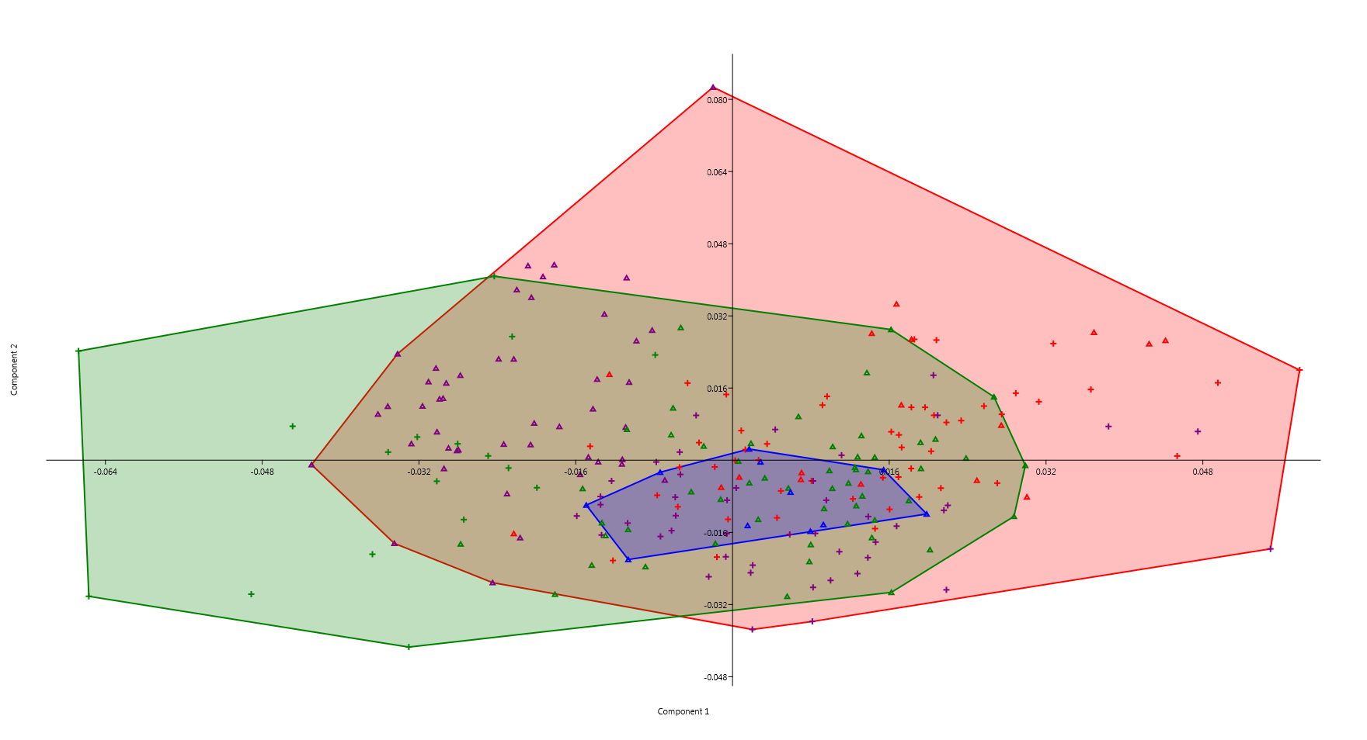

Second graph[State]- Red (Amazonas), Purple (Rondonia), Green (Tocantins), Blue (Rio de Janeiro)

